Example 1
Source https://github.com/oneapi-src/oneAPI-samples/blob/main/DirectProgramming/C%2B%2BSYCL/DenseLinearAlgebra/matrix_mul/README.md
Matrix Multiply Sample
The Matrix Multiply is a simple program that multiplies together two large matrices and verifies the results. This program uses two methods to accomplish the same operations: SYCL* and OpenMP (OMP).
Property | Description
What you will learn | How to offload computations on 2D arrays to a GPU using SYCL* and OpenMP.
Time to complete | 15 minutes
Note: This Matrix Multiply sample does not support OpenMP on Windows.
Purpose
The Matrix Multiply sample program includes SYCL*-compliant and OpenMP C++ implementations. Each implementation is contained in an appropriately named file: matrix_mul_sycl.cpp and matrix_mul_omp.cpp. The separation provides a way to compare existing offload techniques such as OpenMP with SYCL* within a relatively simple sample.
The code will attempt to execute on an available GPU first and fallback to the system CPU if a compatible GPU is not detected. The device used for the compilation is displayed in the output.
Prerequisites
Optimized for | Description
OS | Linux* Ubuntu* 18.04  Windows* 10, 11
Hardware | Skylake with GEN9 or newer
Software | Intel® oneAPI DPC++/C++ Compiler  Intel® oneAPI C++ Compiler Classic  Intel® C++ Compiler
Key implementation details
Since the sample multiples two large matrices, this sample is a slightly more complex computation than the Vector Add sample. This sample uses buffers to manage memory. (For more information on different memory management options, refer to the Vector Add sample.)
The default sample builds the SYCL*-compliant application, and separate OpenMP build instructions are included below.
The code attempts to run the calculation on both the GPU and CPU and verify the results. The size of the computation can be adjusted for heavier workloads. If successful, the name of the offload device and a success message is displayed.
Build the Matrix Multiply Samples
Setting Environment Variables
When working with the Command Line Interface (CLI), you should configure the oneAPI toolkits using environment variables. Set up your CLI environment by sourcing the setvars script every time you open a new terminal window. This practice ensures your compiler, libraries, and tools are ready for development.
Note: If you have not already done so, set up your CLI environment by sourcing the setvars script located in the root of your oneAPI installation.
Linux*:
- For system wide installations: . /opt/intel/oneapi/setvars.sh
- For private installations: . ~/intel/oneapi/setvars.sh
- For non-POSIX shells, like csh, use the following command: $ bash -c 'source <install-dir>/setvars.sh ; exec csh'
Windows*:
- C:\"Program Files (x86)"\Intel\oneAPI\setvars.bat
- For Windows PowerShell*, use the following command: cmd.exe "/K" '"C:\Program Files (x86)\Intel\oneAPI\setvars.bat" && powershell'
Microsoft Visual Studio:
- Open a command prompt window and execute setx SETVARS_CONFIG " ". This only needs to be set once and will automatically execute the setvars script every time Visual Studio is launched.
For more information on environment variables, see "Use the setvars Script" for Linux or macOS, or Windows.
You can use Modulefiles scripts to set up your development environment. The modulefiles scripts work with all Linux shells.
If you wish to fine tune the list of components and the version of those components, use a setvars config file to set up your development environment.
Using Visual Studio Code* (Optional)
You can use Visual Studio Code (VS Code) extensions to set your environment, create launch configurations, and browse and download samples.
The basic steps to build and run a sample using VS Code include:
- Download a sample using the extension Code Sample Browser for Intel Software Developer Tools.
- Configure the oneAPI environment with the extension Environment Configurator for Intel Software Developer Tools.
- Open a Terminal in VS Code (Terminal>New Terminal).
- Run the sample in the VS Code terminal using instructions below.
To learn more about the extensions and how to configure the oneAPI environment, see the Using Visual Studio Code with Intel® oneAPI Toolkits User Guide.
On Linux
Build for SYCL*
- Build the program.
- make all
Build for OpenMP
- Build the program using Make
- make build_omp
On Windows
Build for SYCL*
Note: The OpenMP offload target is not supported on Windows.
- Build using nmake.
- nmake -f Makefile.win build_sycl
On Windows* Using Visual Studio*
- Build the program using VS2017 or later.
  - Right-click on the solution file and open using the IDE.
  - Right-click on the project in Solution Explorer and select Rebuild.
  - From the top menu, select Debug > Start without Debugging.
- Build the program using MSBuild.
  - Open "x64 Native Tools Command Prompt for VS2017" or "x64 Native Tools Command Prompt for VS2019" or whatever is appropriate for your Visual Studio version.
  - Run the following command: MSBuild matrix_mul.sln /t:Rebuild /p:Configuration="release"
Troubleshooting
If you receive an error message, troubleshoot the problem using the Diagnostics Utility for Intel® oneAPI Toolkits. The diagnostic utility provides configuration and system checks to help find missing dependencies, permissions errors and other issues. See the Diagnostics Utility for Intel® oneAPI Toolkits User Guide for more information on using the utility.
Run the Matrix Multiply Samples
On Linux
- Run both versions.
- make run
- make run_omp
On Windows
- Run the SYCL version.
- nmake -f Makefile.win run_sycl
- Alternatively, change directory to the output folder and run the .exe file. (Depending on the build method you selected, the .exe name could be different from what is shown.)
- matrix_mul_sycl.exe
Application Parameters
You can modify the computation size by adjusting the size parameter in the matrix_mul_sycl.cpp and matrix_mul_omp.cpp files. You can configure the following parameters in both files:
size = m_size = 150*8; // Must be a multiple of 8.
M = m_size / 8;
N = m_size / 4;
P = m_size / 2;
Note: The size value must be in multiples of 8.
Example Output
./matrix_mul_dpc
Device: Intel(R) Iris(R) Xe Graphics
Problem size: c(150,600) = a(150,300) * b(300,600)
Result of matrix multiplication using SYCL: Success - The results are correct!

Example 2
Source https://www.intel.com/content/www/us/en/docs/mpi-library/get-started-guide-windows/2021-11/overview.html

Get Started with Intel® MPI Library for Intel® oneAPI on Windows* OS
The Intel® MPI Library enables you to create, maintain, and test advanced applications that have performance advantages on high-performance computing (HPC) clusters based on Intel® processors.
The Intel MPI Library is available as a standalone product and as part of the Intel® HPC Toolkit.The Intel MPI Library is a multi-fabric message passing library that implements the Message Passing Interface, version 3.1 (MPI-3.1) specification. Use the library to develop applications that can run on multiple cluster interconnects.
The Intel MPI Library has the following features:
- Low overhead enables analysis of large amounts of data
- MPI tuning utility for accelerating your applications
- Interconnect independence and flexible runtime fabric selection
The product consists of the following main components:
- Compilation tools, including compiler drivers such as mpiicc and mpifort
- Include files and modules
- Dynamic (.dll) libraries, debug libraries, interface libraries, and program database(.pdb) files
- Process Manager and tools to run programs
- Test code
- Documentation provided as a separate package or available from the Intel Developer Zone
Intel MPI Library also includes Intel® MPI Benchmarks, which enable you to measure MPI operations on various cluster architectures and MPI implementations. For details, see the Intel® MPI Benchmarks User Guide. Source code is available in the GitHub repository.
For other more information on using the Intel MPI Library see Intel® MPI Library Developer Guide for Windows* OS and Intel® MPI Library Developer Reference for Windows* OS.

Key Features
The Intel MPI Library has the following major features:
- MPI-1, MPI-2.2 and MPI-3.1 specification conformance
- Interconnect independence
- Supported Languages:
  - For GNU* compilers: C, C++, Fortran 77, Fortran 95
  - For Intel® compilers: C, C++, Fortran 77, Fortran 90, Fortran 95

Building and Running MPI Programs

Compiling an MPI Program
1. Run the setvars.bat script to set the environment variables for the Intel MPI Library. The script is located in the installation directory (by default, C:\Program Files (x86)\Intel\oneAPI).
NOTE:
If you are using Intel MPI in a Unified Directory Layout, set the environment variables using the C:\Program Files (x86)\Intel\oneAPI\<toolkit-version-number>\oneapi_setvars.bat script instead. To understand more about the Unified Directory Layout, including how the environment is initialized and the advantages of using the layout, see Use the setvars and oneapi-vars Scripts with Windows*.
2. Make sure you have the desired compiler installed and configured properly. For example, for the Intel® C++ Compiler, run:
> icl
If the command is not recognized, add the compiler to your PATH. For the Intel® compilers, you can run the vars.bat script from corresponding directory.
3. Compile your program using the appropriate compiler driver. For example, for a test C program:
> mpiicc -o test.exe <install-dir>\test\test.c
For detailed system requirements, see Intel® MPI Library System Requirements.

Running an MPI Program
Execute the program using the mpiexec command. For example, for the test program:
> mpiexec -n <# of processes> test.exe
To specify the hosts to run the program on, use the -hosts option:
> mpiexec -n <# of processes> -ppn <# of processes per node> -hosts <host1>,<host2>,...,<hostN> test.exe

Troubleshooting
If you encounter problems when using Intel MPI Library, go through the following general procedures to troubleshoot them:
- Check known issues and limitations in the Release Notes.
- Check hosts accessibility. Run a simple non-MPI application (for example, hostname utility) on the problem hosts with mpiexec. This check helps you reveal an environmental problem , or connectivity problem (for example, unreachable hosts).
- Run the MPI application with debug information enabled. To enable the debug information, set the environment variable I_MPI_DEBUG=6. You can also set a different debug level to get more detailed information. This action helps you find the problem component.
See more details in the “Troubleshooting” section of the Developer Guide.

Example 3
Source https://www.intel.com/content/www/us/en/docs/gpa/user-guide/2024-3/graphics-trace-analyzer-window-open-trace-capture.html

Open Trace Capture
Use the Open Trace Capture window to select and open your trace file.
To access the Open Trace Capture window, in the Intel® GPA context menu, select Graphics Trace Analyzer. On Windows* OS, if you opted to enable context menu entries during installation, you can also open trace files using the Windows context menu.
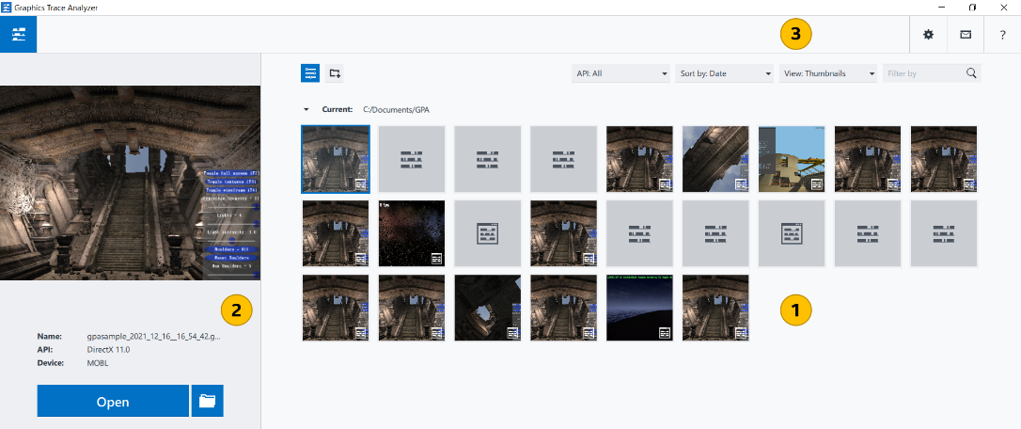

 | Trace Capture Thumbnails pane  Select the trace capture you want to debug. By default, this field lists all trace captures located in your Intel GPA home directory: %USERPROFILE%\Documents\GPA (Windows* OS). You can sort the trace captures by name or date with the Sort by button. If there are no trace captures on your system, these toggle buttons are hidden. The currently selected trace capture is highlighted with blue borders and appears in the trace preview pane.  Trace file thumbnails are marked with the icon. If the captured trace data is invalid, the thumbnail is marked with the  icon.  To delete captured traces, hover the mouse pointer over a trace thumbnail and click the Close button in the top right-hand corner of the thumbnail. Confirm your choice by clicking Yes on the thumbnail.
 | Preview pane  Preview the selected trace captures. This field shows the buffer image and the following trace capture properties:  - File name  - API used  - Name of the device on which the trace was captured  To rename the selected trace capture, you can click its filename and enter a new value. Click Open, to open the selected trace in the Platform View. Click the Show in Folder button to open the storage directory of the selected trace.
 | Message pane  View the Intel GPA messages or notifications.

Type filter expression field | Filter the displayed trace capture files by typing in a part of the trace file name.
Run Graphics Monitor button | Click to capture new traces with Graphics Monitor.
Settings button | Manage Graphics Trace Analyzer settings: 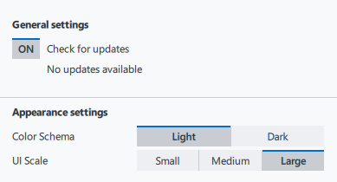  If a newer version of the product is available, the Settings button is marked with the exclamation mark. To download the update, click the Settings button and select the available version from the context menu.  - Use the General Settings toggle button to enable/disable checking for the newest available version of Graphics Trace Analyzer.  NOTE:  During this check, Graphics Trace Analyzer collects information about your host system. No personally identifiable information is collected.  - Use the Color scheme setting to change the palette of the Graphics Trace Analyzer interface from Light (default) to Dark.  - Use the UI Scale setting to change the size of the Graphics Trace Analyzer screen and the screen elements. Large size is default.
Help button | Open Intel GPA online documentation.

See Also
Identify Issues in Graphics Application Execution with Trace Analyzer

